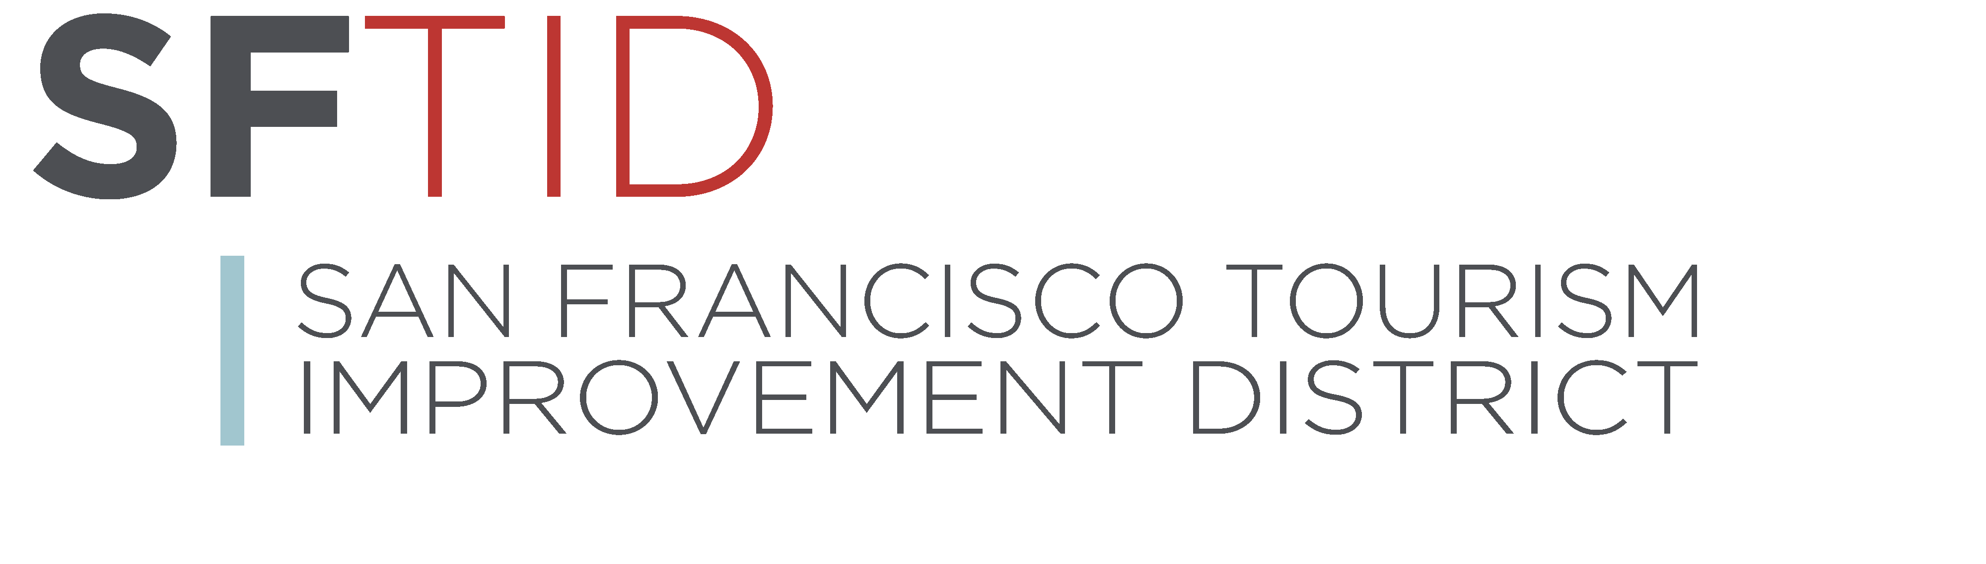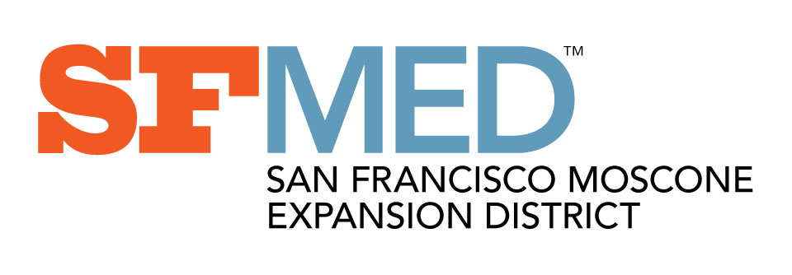

Board of Directors Meeting
December 5, 2018 8:30 a.m.
San Francisco Travel Office
One Front Street, Ste 2900
San Francisco, CA 94111

AGENDA
Estimated Time
8:30 a.m. | I. | CALL MEETING TO ORDER
8:30 a.m. | II. | CORPORATION POLICIES
- Anti-Trust Compliance
- Conflict of Interest
8:33 a.m. | III. | PERSONS WISHING TO ADDRESS THE BOARD ON ITEMS NOT ON THE AGENDA
8:36 a.m. | V. | Moscone Expansion Report
UPDATE: Status of project.
- Construction Status
- Schedule
- Budget
- Sales/Client Update

 |  | UPDATE: Grand Opening Celebration Planning
9:00 a.m. | VI. | SF Travel Update  - Moscone Groups At-Risk
9:25 a.m. | VII. | FUTURE BOARD AGENDA ITEMS
9:28 a.m. | VIII. | FUTURE BOARD MEETING DATES
9:30 a.m. | IX. | ADJOURNMENT
The Board of Directors welcomes participation by the public. A person wishing to speak on any item on or off the agenda will be granted up to 3 minutes. The Board will limit the public comment period on any single item to 15 minutes. Members of the public are invited to submit comments in writing. An opportunity is provided for the public to address the Board on items not appearing on the agenda. However, in compliance with Board policy and the Brown Act, the Board is not permitted to discuss or take action on non-agenda items. Estimated times are approximate; actual times may vary. Members of the public who are interested in particular agenda items may wish to arrive early. Assistance will be provided to those requiring accommodations for disabilities in compliance with the Americans with Disabilities Act of 1990. Interested persons must request accommodations at least 48 hours in advance of the meeting by contacting the San Francisco Travel Association, (415) 227-2605. Any documents related to an agenda item for open session of a regular board meeting and distributed less than 72 hours before the meeting may be inspected at the Offices of San Francisco Travel Association, One Front Street, Ste 2900, San Francisco, CA 94111.

